CREATE TABLE Tickets (

Ticket_ID INT PRIMARY KEY,

Event_Name VARCHAR(100),

Event_Date DATE,

Ticket_Price DECIMAL(10, 2),

Quantity_Sold INT

);

INSERT INTO Tickets (Ticket_ID, Event_Name, Event_Date, Ticket_Price, Quantity_Sold)

VALUES

(1, 'Concert A', TO_DATE('2024-08-01', 'YYYY-MM-DD'), 50.00, 200),

(2, 'Concert B', TO_DATE('2024-08-01', 'YYYY-MM-DD'), 75.00, 150),

(3, 'Concert C', TO_DATE('2024-08-02', 'YYYY-MM-DD'), 60.00, 100),

(4, 'Theater A', TO_DATE('2024-08-03', 'YYYY-MM-DD'), 40.00, 250),

(5, 'Theater B', TO_DATE('2024-08-03', 'YYYY-MM-DD'), 55.00, 300);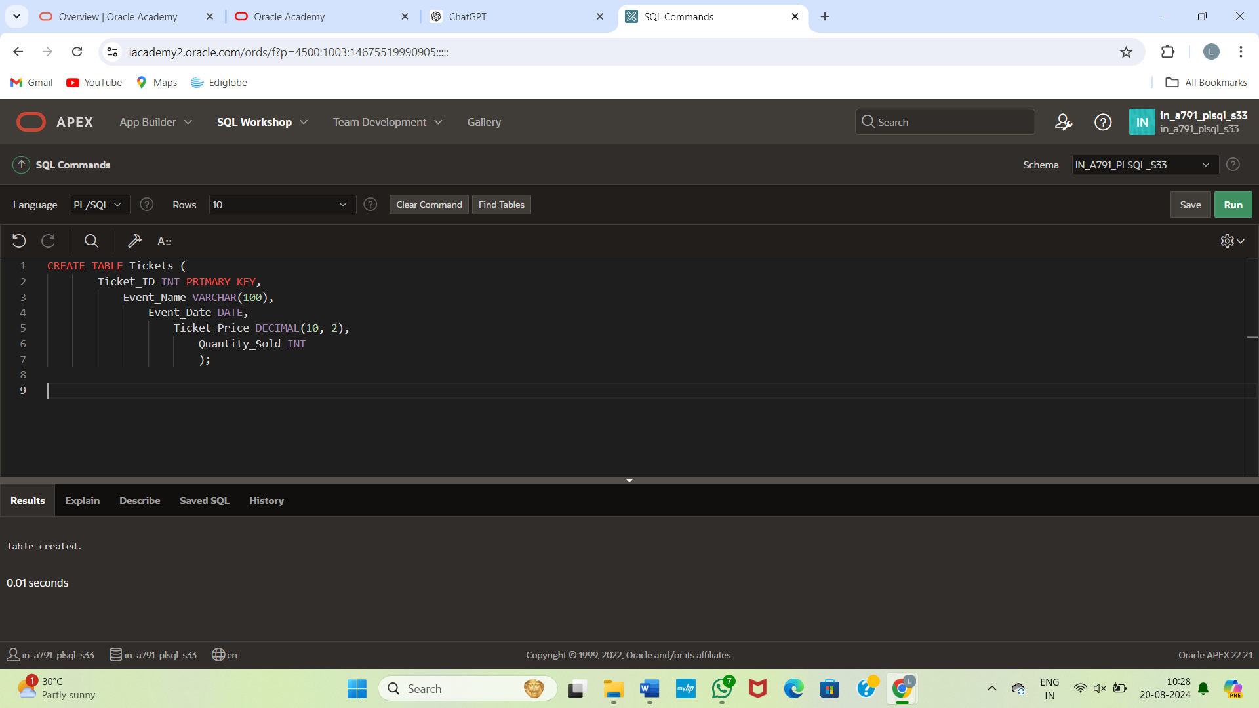

CREATE TABLE Expenses (

Expense_ID INT PRIMARY KEY,

Expense_Date DATE,

Description VARCHAR(255),

Amount DECIMAL(10, 2)

);

INSERT INTO Expenses (Expense_ID, Expense_Date, Description, Amount)

VALUES

(1, TO_DATE('2024-08-01', 'YYYY-MM-DD'), 'Venue Rental', 3000.00),

(2, TO_DATE('2024-08-01', 'YYYY-MM-DD'), 'Advertising', 1500.00),

(3, TO_DATE('2024-08-02', 'YYYY-MM-DD'), 'Catering', 800.00),

(4, TO_DATE('2024-08-03', 'YYYY-MM-DD'), 'Sound System Rental', 1200.00),

(5, TO_DATE('2024-08-03', 'YYYY-MM-DD'), 'Staff Salaries', 2000.00);

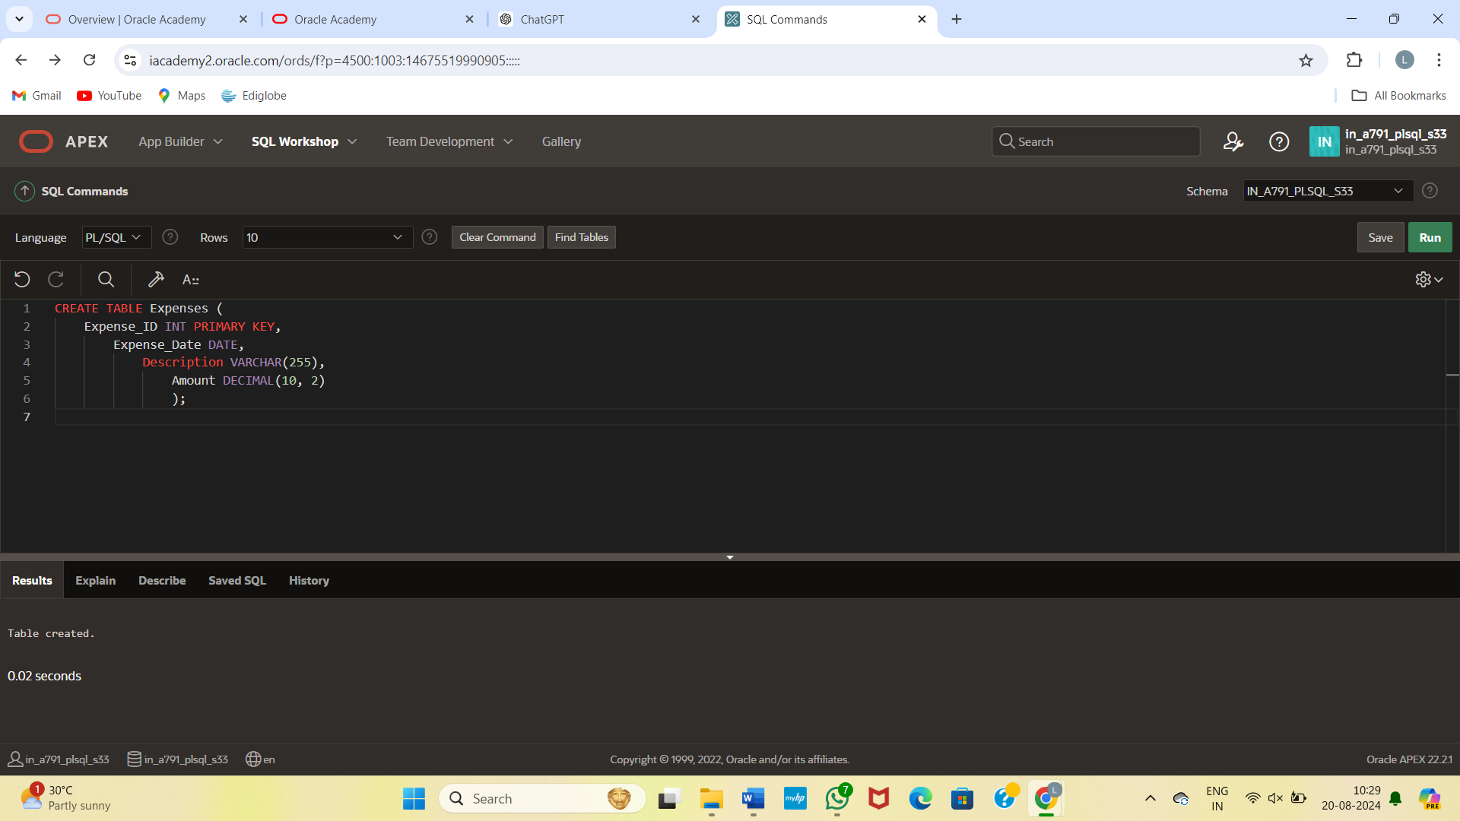

CREATE TABLE Profit_Loss (

Profit_Loss_ID INT PRIMARY KEY,

Profit_Loss_Date DATE UNIQUE,

Total_Sales DECIMAL(10, 2),

Total_Expenses DECIMAL(10, 2),

Profit_Loss_Amount DECIMAL(10, 2)

);

INSERT INTO Profit_Loss (Profit_Loss_ID, Profit_Loss_Date, Total_Sales, Total_Expenses, Profit_Loss_Amount)

VALUES

(1, TO_DATE('2024-08-01', 'YYYY-MM-DD'), 0.00, 0.00, 0.00),

(2, TO_DATE('2024-08-02', 'YYYY-MM-DD'), 0.00, 0.00, 0.00),

(3, TO_DATE('2024-08-03', 'YYYY-MM-DD'), 0.00, 0.00, 0.00);

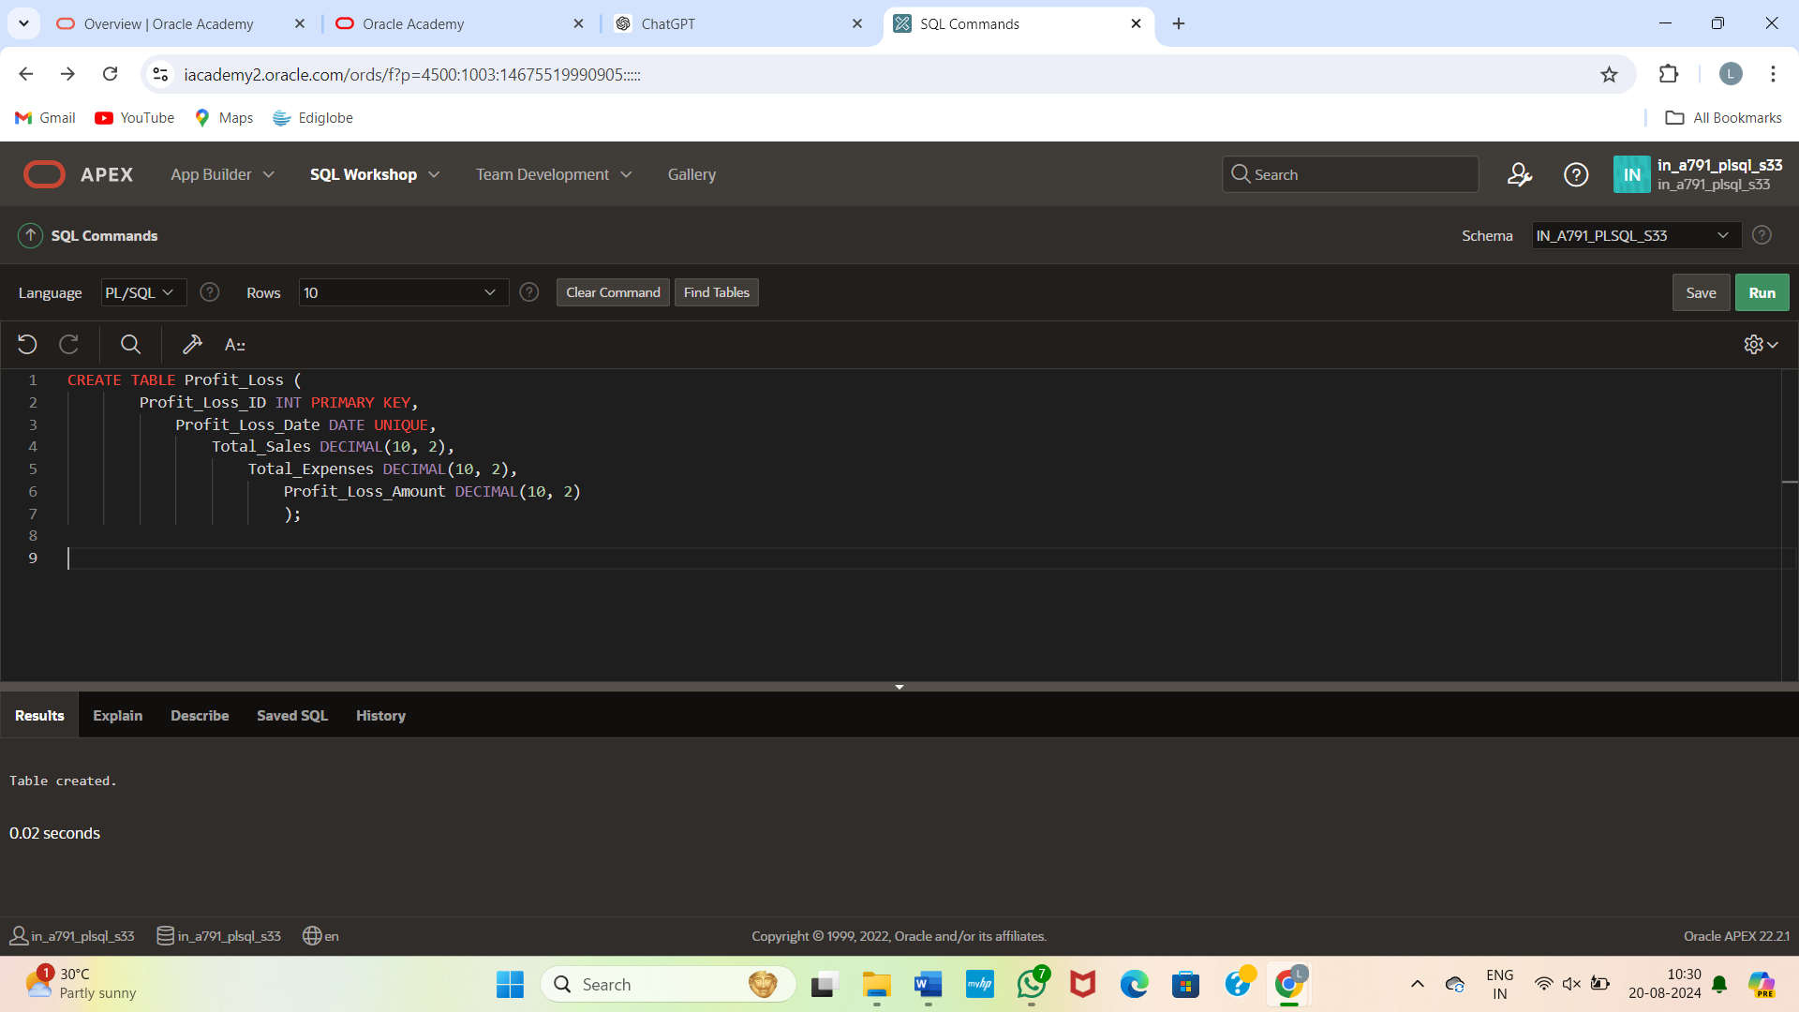

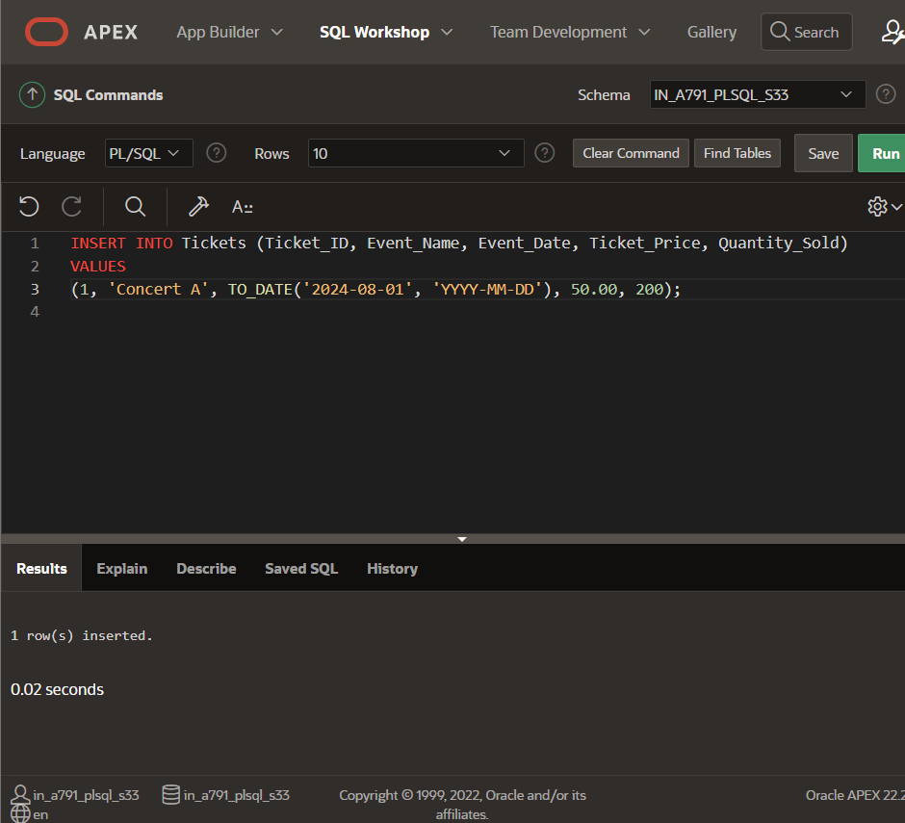

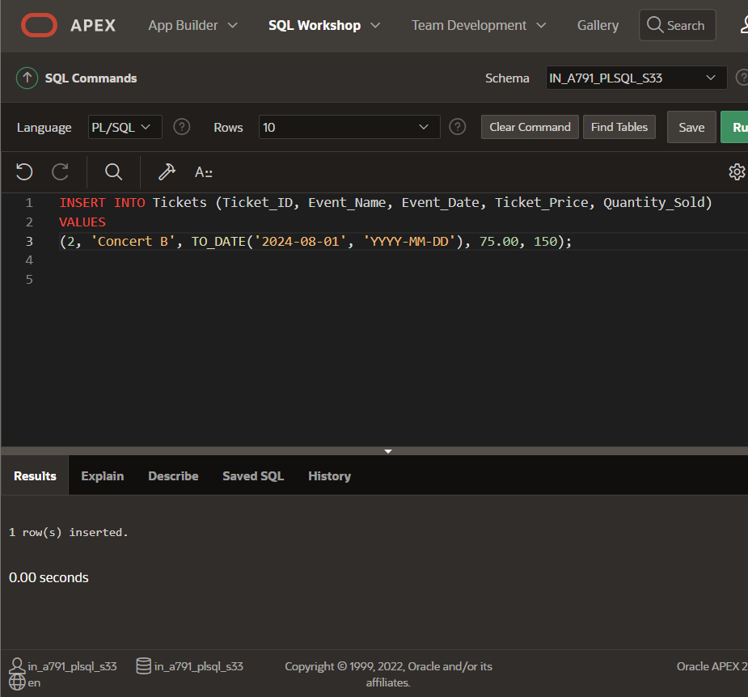

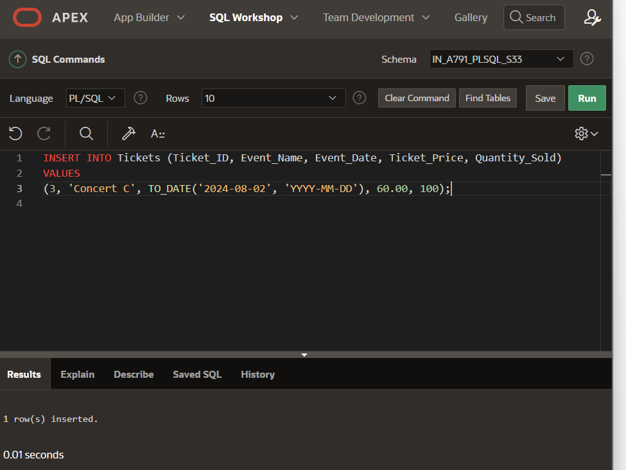

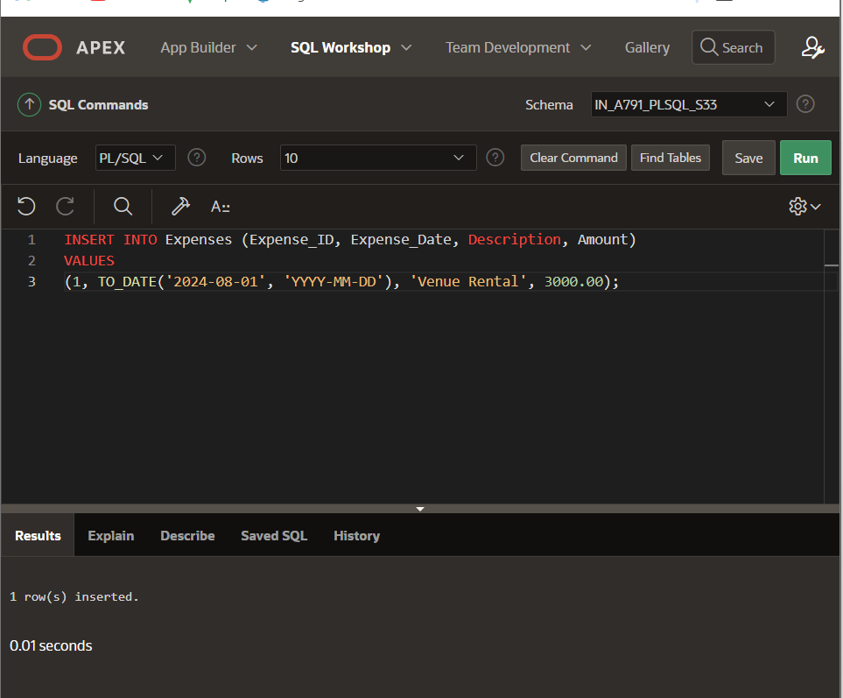

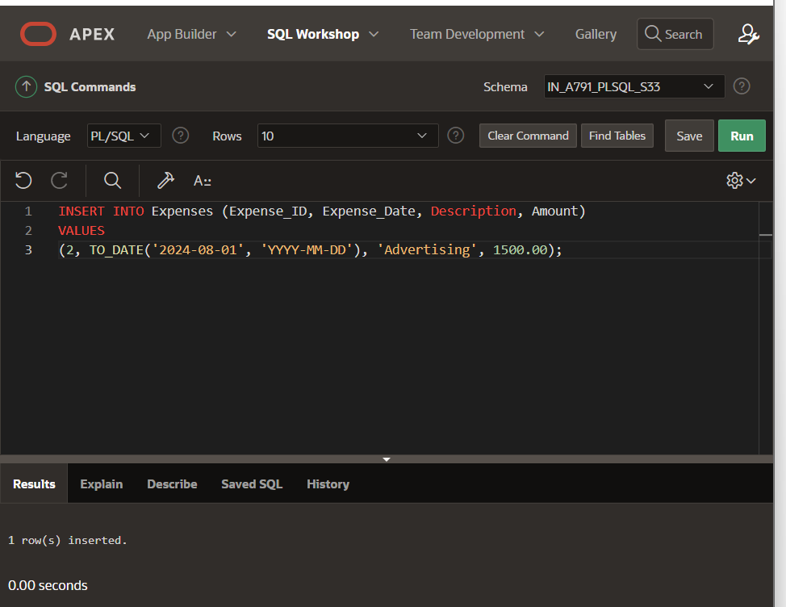

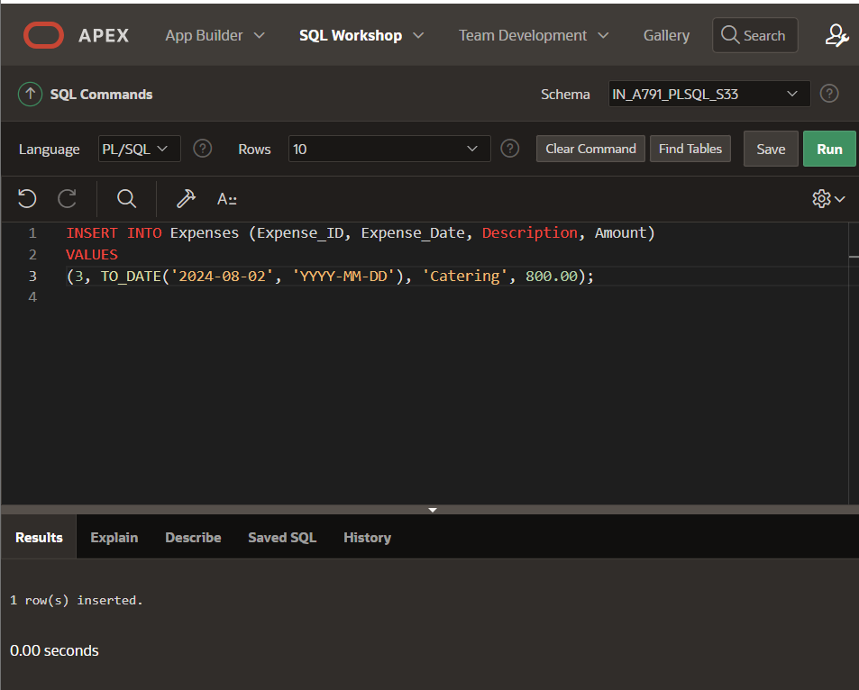

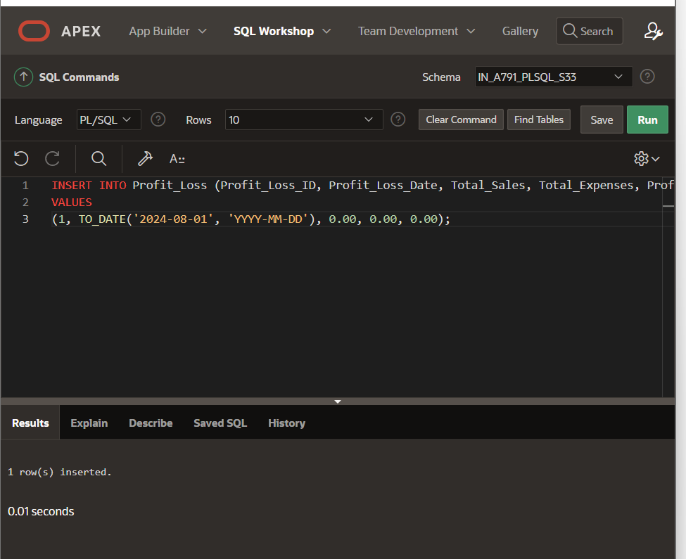

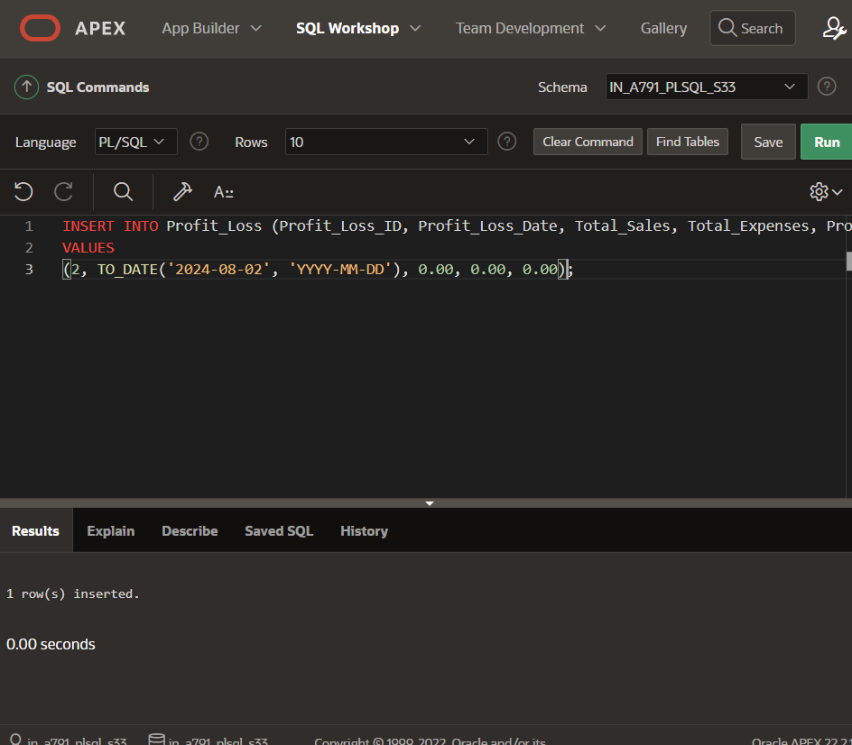

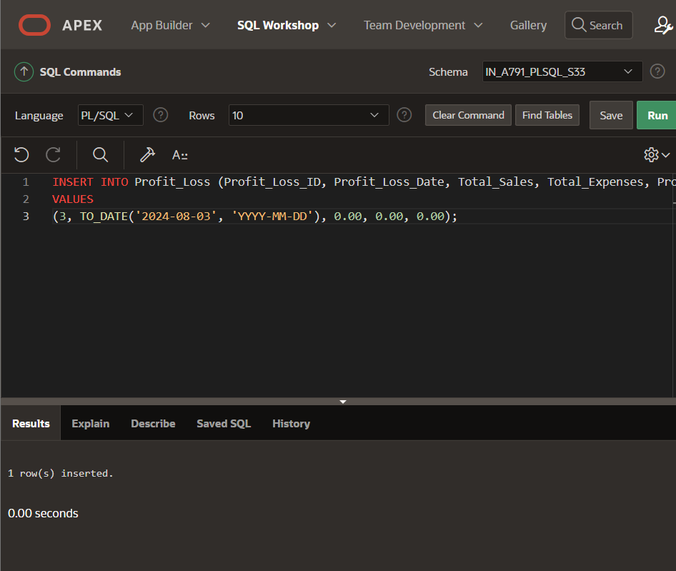

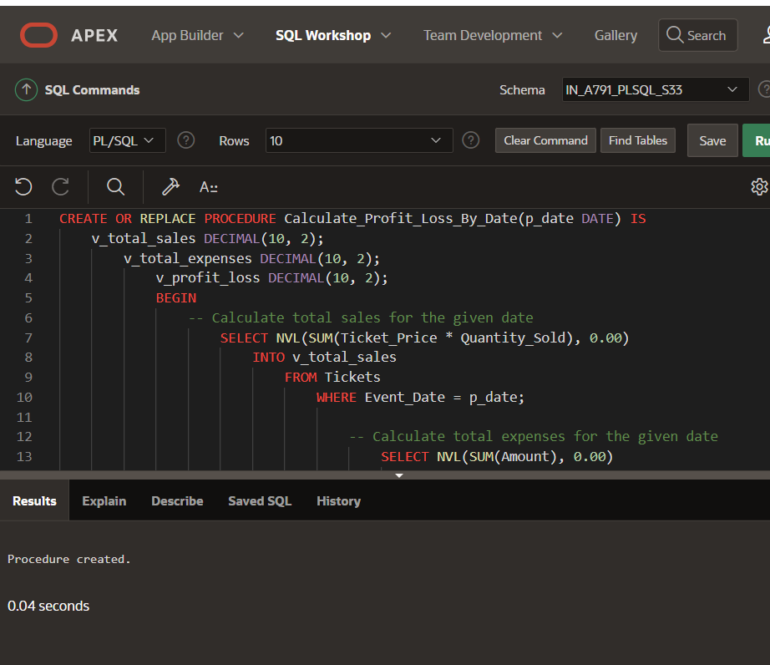

CREATE OR REPLACE PROCEDURE Calculate_Profit_Loss_By_Date(p_date DATE) IS

v_total_sales DECIMAL(10, 2);

v_total_expenses DECIMAL(10, 2);

v_profit_loss DECIMAL(10, 2);

BEGIN

-- Calculate total sales for the given date

SELECT SUM(Ticket_Price * Quantity_Sold)

INTO v_total_sales

FROM Tickets

WHERE Event_Date = p_date;

-- Calculate total expenses for the given date

SELECT SUM(Amount)

INTO v_total_expenses

FROM Expenses

WHERE Expense_Date = p_date;

-- Calculate profit or loss

v_profit_loss := v_total_sales - v_total_expenses;

-- Insert or update the Profit_Loss table

MERGE INTO Profit_Loss pl

USING (SELECT p_date AS Profit_Loss_Date FROM dual) d

ON (pl.Profit_Loss_Date = d.Profit_Loss_Date)

WHEN MATCHED THEN

UPDATE SET

Total_Sales = v_total_sales,

Total_Expenses = v_total_expenses,

Profit_Loss_Amount = v_profit_loss

WHEN NOT MATCHED THEN

INSERT (Profit_Loss_ID, Profit_Loss_Date, Total_Sales, Total_Expenses, Profit_Loss_Amount)

VALUES (Profit_Loss_SEQ.NEXTVAL, p_date, v_total_sales, v_total_expenses, v_profit_loss);

COMMIT;

END;

/

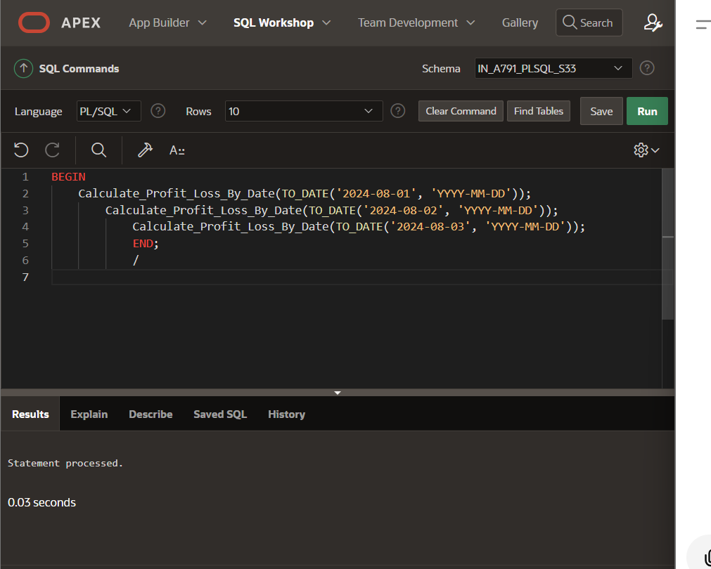

BEGIN

Calculate_Profit_Loss_By_Date(TO_DATE('2024-08-01', 'YYYY-MM-DD'));

Calculate_Profit_Loss_By_Date(TO_DATE('2024-08-02', 'YYYY-MM-DD'));

Calculate_Profit_Loss_By_Date(TO_DATE('2024-08-03', 'YYYY-MM-DD'));

END;

/

